**QUAY BANKING REPORT**

**Objective: Integrate CRM data into the Quay Banking Database, ready for querying and analysis. Draw meaningful insights for Regional Operations Managers regarding branch performance to inform strategy in order to mitigate data silo-isation.**

**SCHEMA DIAGRAM**



**JOINING TABLES**

ALTER TABLE CRM_Call_Center_Logs

ADD CONSTRAINT FK_CRM_Call_Center_Logs

FOREIGN KEY (Complaint_ID)

REFERENCES CRM_Events(Complaint_ID);

ALTER TABLE CRM_Events

ADD CONSTRAINT fk_client_id

FOREIGN KEY (client_id)

REFERENCES Client(client_id);

ALTER TABLE CRM_Reviews

ADD CONSTRAINT fk_district_id

FOREIGN KEY (district_id)

REFERENCES District(district_id);

ALTER TABLE Client

ADD CONSTRAINT fk_district_id

FOREIGN KEY (district_id)

REFERENCES District(district_id);

**QUERIES**

-1) Performance:

--a. Which 20% of branches are underperforming? – evident in “closed complaints without relief” and negative customer service feedback

SELECT TOP 20 percent d.bank_branch

, COUNT(r.Rating) AS negative_rating

FROM District d

left join Client cl on d.district_id = cl.district_id

inner join CRM_Events cr on cl.client_id = cr.Client_ID

inner join CRM_Reviews r on r.District = d.district_id

WHERE cr.Company_response_to_consumer = 'Closed without relief' AND Rating <=1

Group by d.bank_branch

ORDER BY negative_rating desc

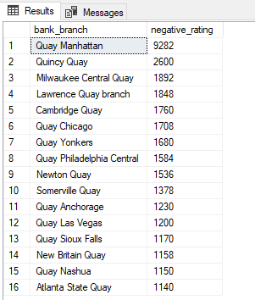

--i. Can we rank the Call Centre Servers’ performance according to Call duration and outcome ? (Advanced)

SELECT [server],

AVG(DATEDIFF(SECOND, ser_start, ser_exit)) as avg_duration,

SUM (CASE WHEN Company_response_to_consumer = 'Untimely response' THEN 1 END) AS NEGATIVE,

SUM (CASE WHEN Company_response_to_consumer = 'In progress' THEN 1 END) AS IN_PROGRESS,

SUM (CASE WHEN Company_response_to_consumer NOT IN ('In progress','Untimely response') THEN 1 END) AS POSITIVE

FROM CRM_logs L

JOIN CRM_Events E ON L.Complaint_ID = E.Complaint_ID

WHERE server is not null

GROUP BY [server]

ORDER BY POSITIVE desc, avg_duration asc

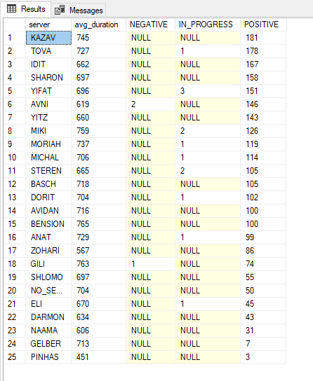

According to Number of Disputes

SELECT L.[server],

AVG(DATEDIFF(SECOND, ser_start, ser_exit)) as avg_duration,

SUM(CASE WHEN E.Consumer_disputed = '1' THEN 1 ELSE 0 END) AS number_disputes

FROM CRM_logs L

JOIN CRM_Events E ON L.Complaint_ID = E.Complaint_ID

WHERE server is not null

GROUP BY [server]

ORDER BY number_disputes desc

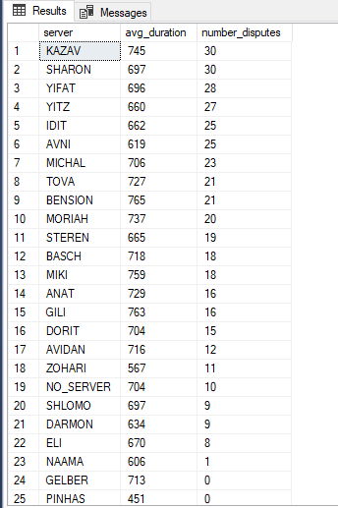

(According to Timely Response)

SELECT L.[server],

AVG(DATEDIFF(SECOND, ser_start, ser_exit)) as avg_duration,

SUM(CASE WHEN E.Timely_response = '1' THEN 1 ELSE 0 END) AS timely_response

FROM CRM_logs L

JOIN CRM_Events E ON L.Complaint_ID = E.Complaint_ID

WHERE server is not null

GROUP BY [server]

ORDER BY timely_response desc

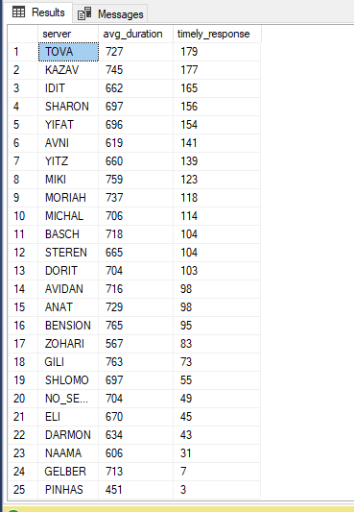

--b. Which are the top 5 branches per positive customer feedback?

SELECT TOP 5 d.bank_branch,

COUNT(r.Review_id) AS Number

FROM District d

inner join CRM_Reviews r on r.District = d.district_id

WHERE r.Rating = 5

GROUP BY d.bank_branch

ORDER BY Number desc

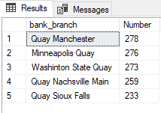

--i. What are the characteristics of these branches that could contribute to this positivity ?Advanced)

SELECT TOP 5 D.bank_branch,

COUNT(R.Rating) AS avg_rating,

D.city,

D.state_name,

D.region,

D.division

FROM CRM_Reviews AS R

JOIN District AS D ON R.District = D.district_id

WHERE R.rating = 5

GROUP BY D.bank_branch, D.city, D.state_name, D.region, D.division

ORDER BY avg_rating DESC

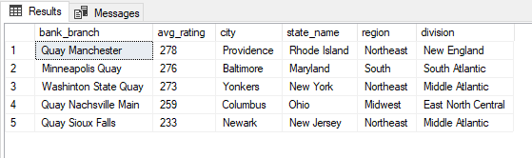

Characteristics- most are in the Northeast regions, in urban areas

--2) Reporting CRM data:

--a. Which branches may be under-reporting their customer feedback? Highlight anything less than 2 standard deviations away from the mean

WITH Branch_count AS (

SELECT D.bank_branch,

COUNT (R.District) AS complaints

FROM District D JOIN CRM_Reviews R ON D.district_id = R.District

GROUP BY D.bank_branch),

Stats AS (SELECT

AVG (complaints) AS Mean,

STDEV(complaints) AS StandardDeviation

FROM Branch_count)

SELECT Branch_count.bank_branch, Branch_count.complaints

FROM Branch_count

JOIN Stats ON 1=1

WHERE Branch_count.complaints < (Mean- (2 * StandardDeviation)) OR Branch_count.complaints > (Mean * StandardDeviation)

ORDER BY complaints;

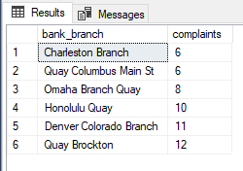

--i. Dive deeper into this pattern by separating branches in urban from those in more rural areas, as best you can. (Advanced)

SELECT bank_branch, city, state_name, region,

CASE WHEN city IN ('Danbury') THEN 'Rural' ELSE 'Urban' END AS branch_type

FROM District

WHERE bank_branch IN ('Charleston Branch', 'Quay Columbus Main St', 'Omaha Branch Quay', 'Honolulu Quay', 'Denver Colorado Branch', 'Quay Brockton')

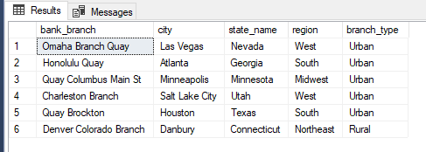

--3) Customer Complaints:

--a. How well are branches and customer service staff handling customer complaints?

--i. Which customer service staff are closing the most queries either as “Closed without relief” or “Closed with Explanation”?

SELECT L.server, COUNT(*) AS num_queries_closed

FROM CRM_Events AS E

INNER JOIN CRM_logs AS L ON E.Complaint_ID = L.Complaint_ID

WHERE E.Company_response_to_consumer IN ('Closed without relief', 'Closed with explanation')

GROUP BY L.server

ORDER BY num_queries_closed desc

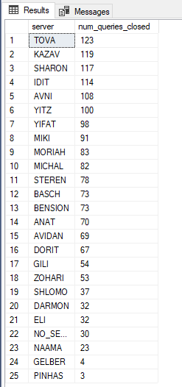

--ii. Which branches are proportionally receiving the most complaints regarding “Account opening, closing, or management”?

SELECT D.bank_branch,

COUNT(*) AS total_complaints,

COUNT(*) * 100.0 / SUM(COUNT(*)) OVER() AS complaint_proportion

FROM CRM_Events AS E

JOIN Client AS C ON E.client_id = C.client_id

JOIN District AS D ON C.district_id = D.district_id

WHERE E.issue = 'Account opening, closing, or management'

GROUP BY D.bank_branch

ORDER BY complaint_proportion DESC;

